[55958- Aman Goswami, Documentation – 2, Date - 12 Dec 2025]
Different types of Models

Agile Methodology
Agile Methodology is a modern and flexible way of developing software that focuses on delivering value to the customer quickly.
Instead of building the entire product at one time, Agile divides the work into small parts called iterations or sprints.
After each small delivery, the team collects feedback and improves the product. This helps teams adapt easily to change and deliver better-quality software in less time.

Agile Manifesto – What Agile Values

Agile is based on the Agile Manifesto, which tells us what is more important during development:

Individuals and interactions are more important than strict processes and tools

Working software is more valuable than heavy documentation

Customer collaboration is better than fixed contracts

Responding to change is better than blindly following a plan

This mindset helps teams stay flexible and focused on real business needs.
Key Principles of Agile
Agile has 12 principles, but the most important ones are:
- Deliver working software frequently
- Accept changes even in the later stages of development
- Business and development teams work closely on a daily basis
- Build projects around motivated and responsible individuals
- Maintain high code quality and technical excellence
- Regularly review work and improve continuously
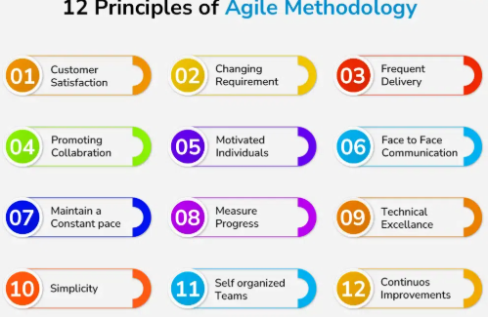

Agile Development Life Cycle (Based on Methodology Phases)
1. Plan
In this phase, the team understands the requirements and decides what work will be done in the sprint.
The Product Owner prioritizes the backlog, and the team selects tasks based on their capacity.
The goal is to create a realistic and achievable plan.
2. Design
A simple and flexible design is prepared for the selected features.
This may include:
- UI mockups
- Basic architecture decisions
- Database or API changes
The design is kept light so it can change if needed.
3. Develop
The development team starts coding the planned features.
Agile encourages:
- Team collaboration
- Pair programming
- Continuous integration
- Daily stand-up meetings
The goal is to have working software by the end of the sprint.
4. Test
Testing is done within the same sprint, not at the end of the project.
QA tests the software for:
- Functionality
- Integration
- Usability
- Regression issues
If defects are found, they are fixed immediately.
5. Deploy
Once the feature is tested and approved, it is deployed to:
- Staging or
- Production environment
Agile teams deploy frequently—sometimes weekly or even daily—so users get benefits faster.
6. Review
At the end of the sprint, the team demonstrates the completed work to the Product Owner or client.
Feedback is collected and discussed.
This ensures the product is:
- Meeting expectations
- Moving in the right direction

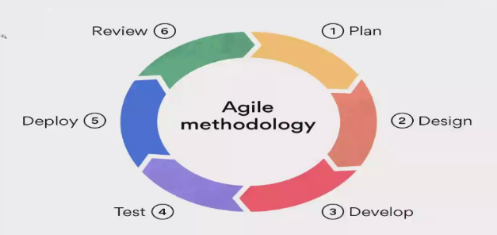
Retrospective (Continuous Improvement)
After the review, the team conducts a Sprint Retrospective.
The team discusses:
- What went well
- What problems were faced
- What can be improved next sprint
This helps the team learn from experience and improve continuously.

Waterfall Model
The Waterfall Model is one of the oldest and most traditional SDLC models used in software development.
It follows a linear, sequential flow, where each phase must be fully completed before moving on to the next.
Because the process flows downward step by step — like a waterfall — the model is named the Waterfall Model.
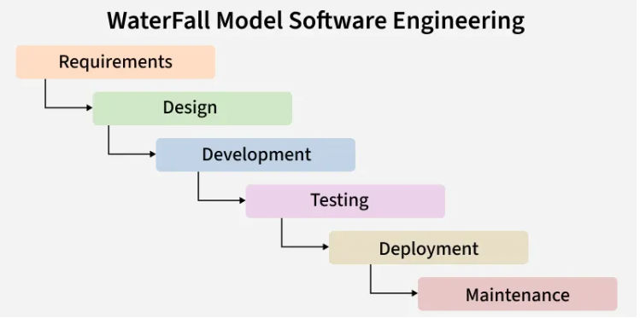

Phases of the Waterfall Model
1. Requirement Analysis
In this phase, the team collects all requirements from the client in complete detail.
A document is prepared that includes:
- What features the system should have
- How the system should behave
- Any limitations
- Performance needs
Since Waterfall does not allow changes later, requirements must be final and clear before moving ahead.
2. System Design
Here, the overall design of the system is created based on the requirements. This includes:
- System architecture
- Database design
- Flow diagrams
This design becomes the blueprint for developers.
3. Implementation (Development)
Developers start writing the actual code.
Each module is built separately, and after all modules are completed, they are combined to form the full system.
4. Integration & Testing
Now all modules are connected and tested together. Testing checks:
- Does the system work as expected?
- Are there any bugs?
- Do all parts work properly together?
Fixing problems at this stage is harder because changes affect earlier phases.
5. Deployment
After testing is complete, the software is delivered to the client.
This may include installing the system, giving training, and preparing real data.
Clients start using the software.
6. Maintenance
Even after deployment, small issues may come up.
The team handles:
- Bug fixes
- Updates
- Small improvements
- Performance fixes
Maintenance keeps the system stable over time.
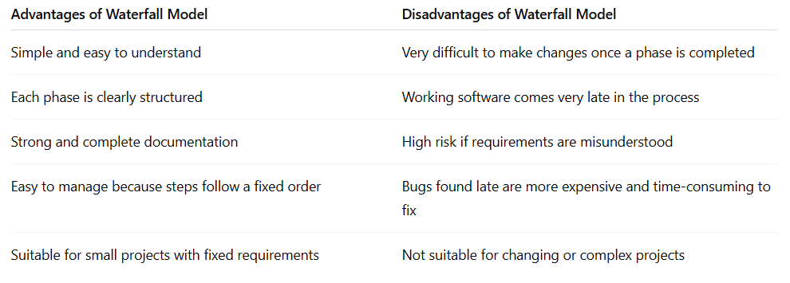

V- Model
The V-Model, also known as the Verification and Validation Model, is an SDLC approach where development and testing activities run in parallel.
It is called the V-Model because the process looks like the letter “V”, where the left side represents verification (planning & design) and the right side represents validation (testing).
The main idea of the V-Model is that each development phase has a corresponding testing phase.
This helps detect mistakes early, making the model more reliable than Waterfall.
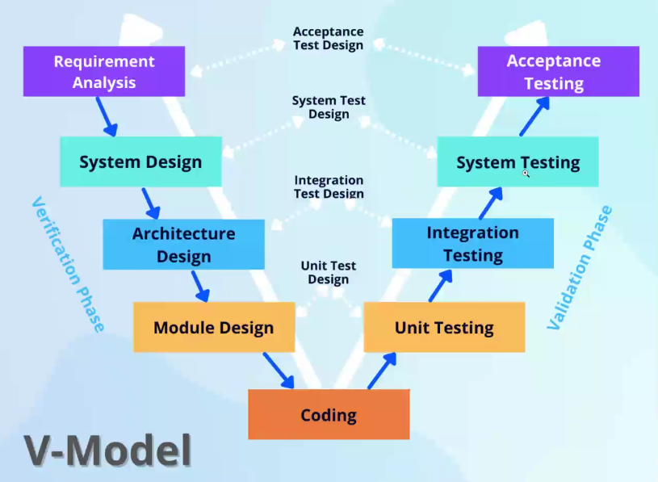

Why the V-Model Is Used
- Testing starts early, even before coding begins
- Reduces the chances of major defects at the end
- Ensures high quality because every stage is verified and validated
- Best suited for projects where requirements do not change frequently

Phases of the V-Model
The V-Model can be divided into two major sides:
Left Side → Verification (Planning & Design)
Right Side → Validation (Testing)
At the bottom of the V is Implementation (Coding).

Verification Phases (Left Side of the V)
1. Requirement Analysis
Here, the team gathers complete requirements from the client.
The output is the User Requirement Document (URD).
This phase matches with User Acceptance Testing (UAT) on the right side.
2. System Design
The system architecture is planned, including:
- Modules
- Database
- Interfaces
- Data flow
This corresponds to System Testing in the validation side.
3. High-Level Design (HLD)
Major components and their interactions are designed.
This includes:
- Module division
- Major functions
- Data tables
- High-level diagrams
This phase aligns with Integration Testing.
4. Low-Level Design (LLD)
This phase focuses on detailed design of each module.
It includes:
- Logic of each function
- Pseudocode
- Detailed workflow
This corresponds to Unit Testing.
Implementation Phase (Bottom of the V)
5. Coding (Development)
All modules are developed based on LLD.
Once coding is complete, the project moves to the validation side, where all testing phases begin.

Validation Phases (Right Side of the V)
6. Unit Testing
Tests each module individually to verify that the code works as expected.
Matches with the Low-Level Design phase.
7. Integration Testing
Tests how different modules work together.
Matches with the High-Level Design phase.
8. System Testing
Ensures the entire system functions correctly according to the design.
Matches with the System Design phase.
9. User Acceptance Testing (UAT)
Performed by the client to verify that:
- The system meets their needs
- All requirements are fulfilled
- The software is ready for real-world use
Matches with Requirement Analysis.

Spiral Model
The Spiral Model is an SDLC approach that combines the iterative nature of Agile with the risk management focus of Waterfall.
The project is developed in repeated cycles (called spirals), and each spiral includes planning, risk analysis, development, and evaluation.
This model is especially useful for large, complex, and high-risk projects where requirements may not be fully known at the beginning.
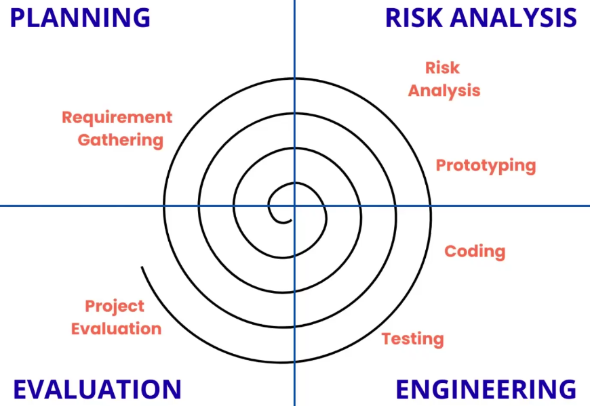

Phases of the Spiral Model
Each spiral cycle contains four major phases:
1. Planning
In this phase, the team identifies:
- Project objectives
- Requirements
- Features to be built in this spiral
- Constraints and priorities
The output is a plan for what will be developed in the current loop.
2. Risk Analysis (Most Important Phase)
Risk analysis is the heart of the Spiral Model.
The team identifies possible risks such as:
- Technical challenges
- Cost overruns
- Integration failures
- Security issues
- Requirement misunderstandings
To reduce these risks, the team may create:
- Prototypes
- Experiments
- Proof-of-concept models
This step ensures that problems are found early before they become costly.
3. Development
Once risks are handled, development begins.
Depending on the project, this phase may include:
- Designing
- Coding
- Testing
- Integrating modules
Small parts of the system are built in each spiral, and the software grows gradually.
4. Evaluation
At the end of the spiral, the client and stakeholders review the progress.
They check if the delivered features meet expectations and decide:
- What changes are needed
- What features should come in the next spiral
- Whether the project should continue or stop
This phase ensures the project stays aligned with real user needs.
